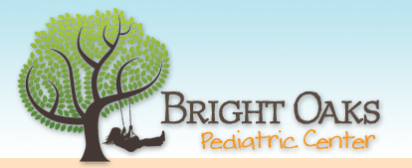 2111 Laurel Bush Rd, Suite H

Bel Air, MD 21015

(410)569-3300

(410)569-8199

www.brightoakspediatrics.com

Below is a list of specialists to whom we usually refer our patients. Please call these offices and inquire if they participate with your insurance plan. If they do, make an appointment then call our office to request a referral if your insurance company requires one. Please notify our office at least 7 working days in advance of the appointment for the referral.

If you have any further questions, please feel free to call our office!

DENTISTS

|  |  |
| --- | --- |
| **Bel Air Smile Partners**  www.belairsmile.com  Bel Air: 410-879-4444  HDG: 410-939-4030 | **Dentistry for Kids**  www.toothfairy2.com  Hunt Valley: 410-771-8200 |
| **Growing Smiles**  www.growingsmiles.com  Bel Air: 410-569-6700  White Marsh: 410-697-9000  HDG: 443-526-7900 | **Mainstreet Children’s Dentistry and Orthodontics**  www.mainstreetsmiles.com  Forest Hill: 410-885-4177  Elkton: 410-648-2211 |
| **Laurel Bush Family Dentistry**  www.laurelbushfamilydentistry.com  (443) 512-8703 | **Fallston Dental Care**  www.fallstondentalcare.com  410-893-0513 |
| **Bel Air Pediatric Dentistry**  www.belairpediatricdentistry.com  443-567-5112 | **Tongue Tie Center of Baltimore**  www.tonguetiecenterofbaltimore.com  410-377-2000 |
| **Dr. Owen Jorden**  Tongue Tie Specialist  Bel Air: 410-838-1166 | **Chesapeake Pediatric Dental**  410-569-4300 |
| **Lifetime Dental Care**  Childhood Sleep Apnea Specialist  Bel Air: 410-879-4363 |  |